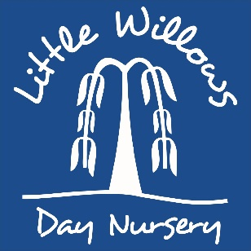
Children’s application form
Home details:
Childs name:
Gender:
Childs date of birth:
Place of address:
Home Contact number:
Parent/carer name: |  | Parent/carer name:
Parent/carer date of birth: |  | Parent/carer date of birth:
National insurance number: |  | National insurance number:
Mobile number: |  | Mobile number:
Email address: |  | Email address:
Type of booking:
 |  |  | Office only
Preferred start date:
Requesting a funded place: | Under 2yr funding code:
Requesting a funded place: | 2yr funding code:
Requesting a funded place: | 3/4yr universal 15hrs funding entitlement?
Requesting a funded place: | 3/4yr 30 hours code:
Requesting a funded place: | Children’s centre funding?
Requesting a funded place: | Any other funding?

Nursery:
Please complete this section. We are an all-year nursery. No term time only spaces offered.
Days | Full day  8.00am-6.00pm | AM-  8.00am-1.00pm | Peak Session  10.30am-3.30pm | PM-  1.00pm-6.00pm | School Day  9.00am-  4.00pm | Breakfast Club  7.30am- 8.00am | Late session  6.00pm-6.30pm | Any ‘bolt on’ hours?
Monday
Tuesday
Wednesday
Thursday
Friday
Please send completed application form with a £50.00 booking fee to Little Willows Day Nursery, Stokes Road, Corsham, Wiltshire, SN13 9AA

Pre-school- FUNDED ONLY place:
Days | Breakfast club- 7.30am-8.00am | AM- 8.00am- 11.00am  (Funded session) | Lunch wrap around care  11.00am-1.00pm | PM-  1.00-4.00pm  (funded session) | Evening wrap around care  4.00pm-6.00pm | Late club  6.00pm-6.30pm
Monday
Tuesday
Wednesday
Thursday
Friday

Office use only:
Date of Application  Received | Date of registration & fee processed: | Date of  place offered: | Date of  place accepted & deposit | Other information

